**LINGI 2315 - Homework 2 - My Bare-metal App P1**

|  |  |  |  |
| --- | --- | --- | --- |
| Name | Delcoigne Ben | Noma | 38771700 |

Description of the software that implements the control of the blinking frequency of LED[0] with relevant screenshots of your code

The software implements are the same as last homework,except now I’m using interrupts to update the frequency instead of in every while loop.

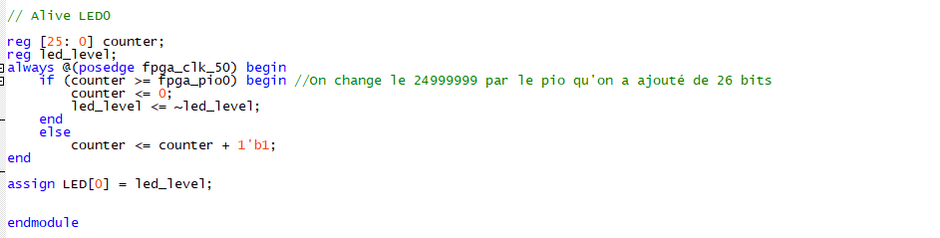

Here is the same function as last time:

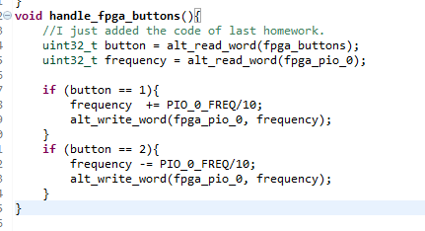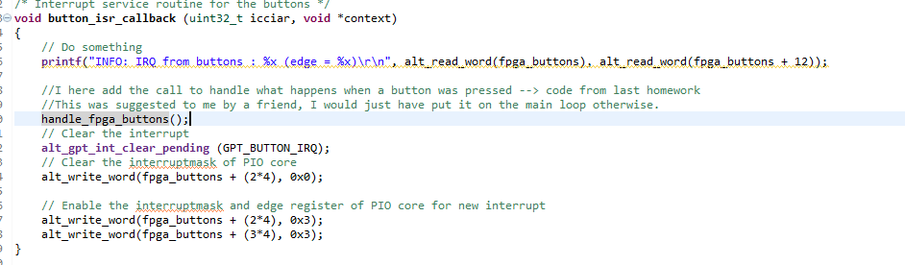

**LINGI 2315 - Homework 2 - My Bare-metal App P2**

|  |  |  |  |
| --- | --- | --- | --- |
| Name |  | Noma |  |

Description of the software the implements the display of 1-axis acceleration with relevant screenshots of your code

I used the same code as given for the button for the interrupts:

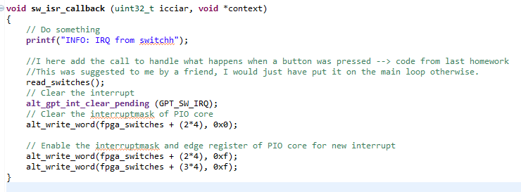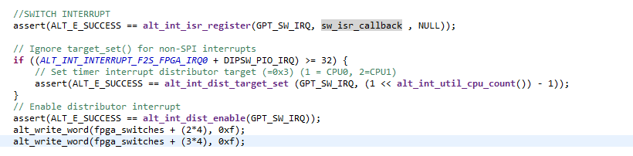

When the interrupt is enabled, i modify a global variable (which stores which switch was on 🡪 the axis we’re reading)

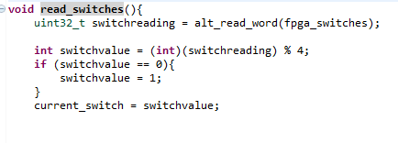

In the main loop, i every time handle the LEDS

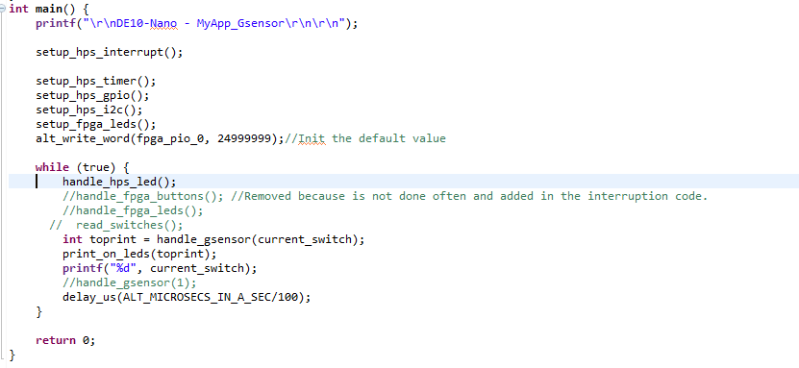

Handle Gsensor reads the value of the gsensor on the selected axis, and then returns the read value

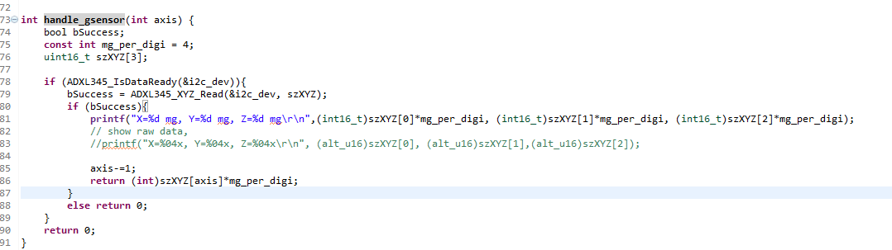

This value is then used to print using print_on_leds();

